**MOCKITO HANDS-ON EXERCISES**

**Exercise 1:** Mocking and Stubbing Scenario: You need to test a service that depends on an external API. Use Mockito to mock the external API and stub its methods.

**File Name:ExternalApi.java**

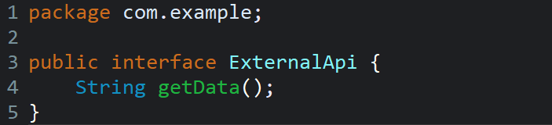

**File Name:MyService.java**

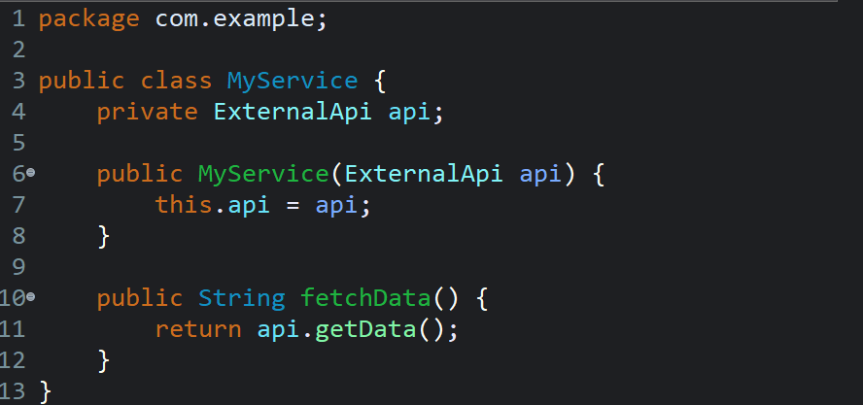

**File Name:MyServiceTest.java**

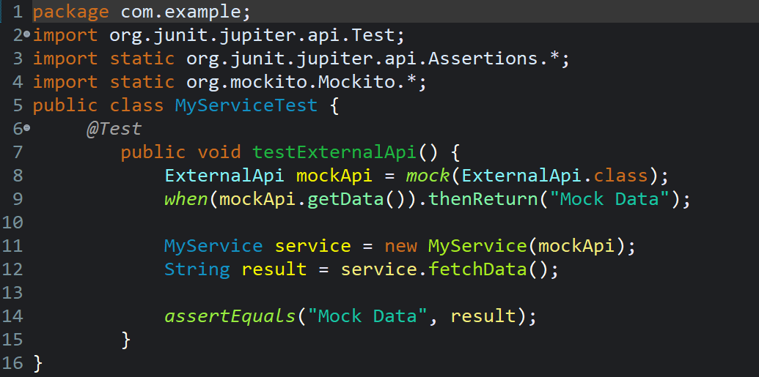

**Output:**

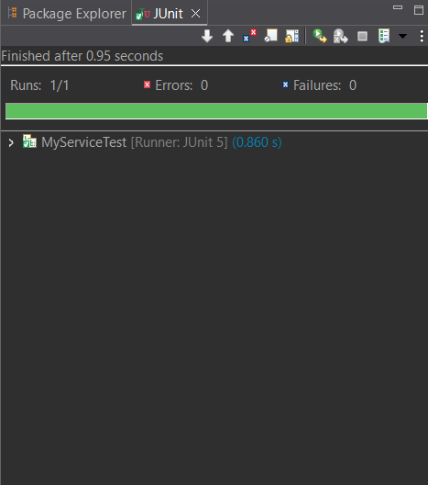

**Exercise 2: Verifying Interactions**

**Scenario:** You need to ensure that a method is called with specific arguments.

**File Name:ExternalApi.java**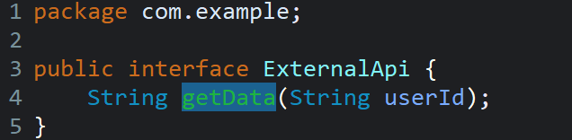

**File Name:MyService.java**

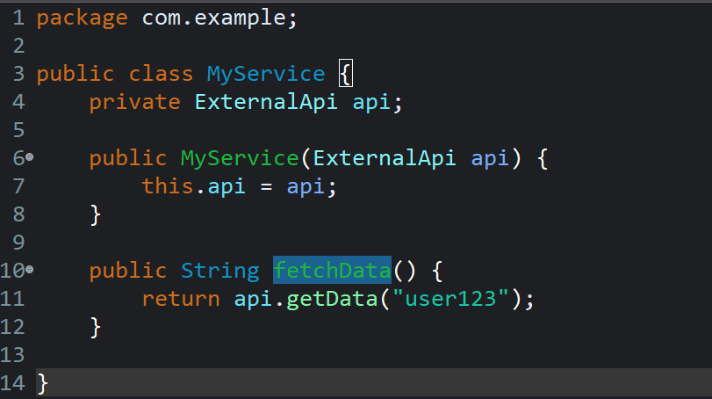

**File Name:MyServiceTest.java**

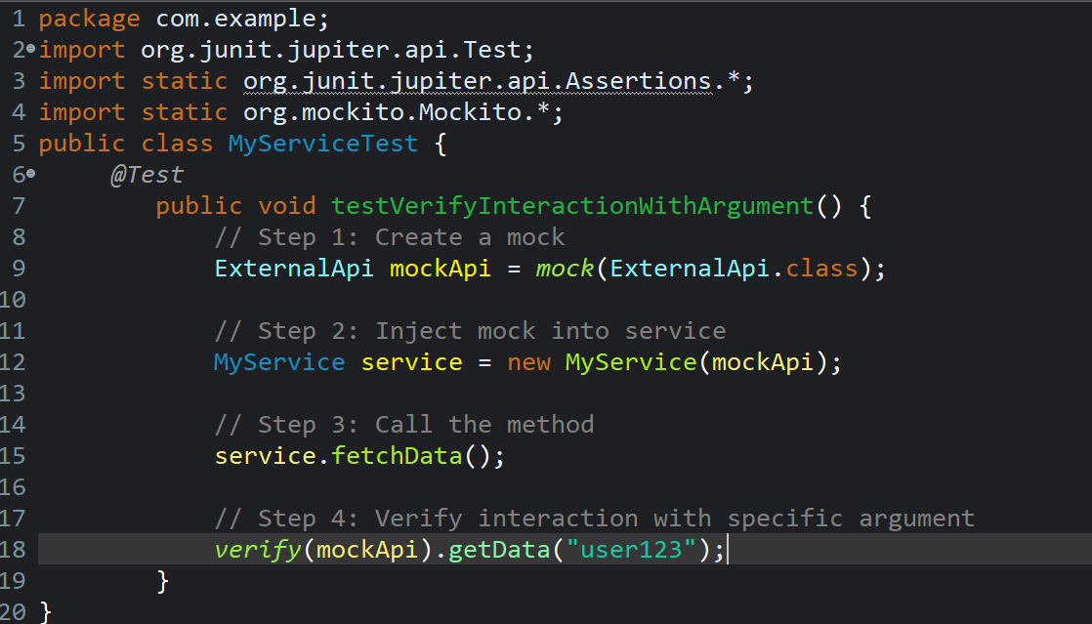

**Output:**

